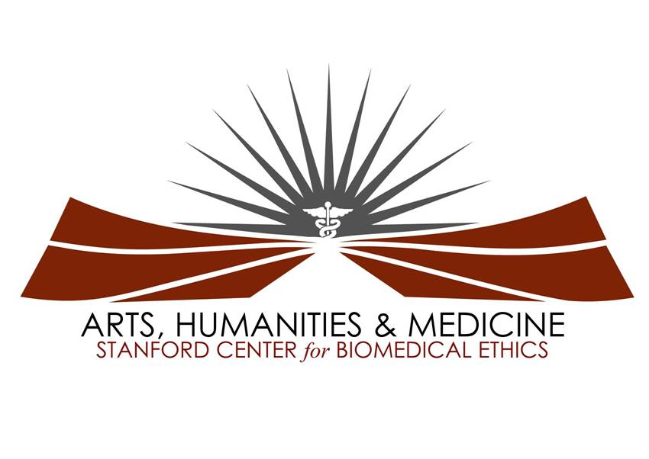

Medicine and the Muse: An Evening of Transcendence

An Arts, Humanities, and Medicine Symposium

Paul and Mildred Berg Hall
Li Ka Shing Center for Learning and Knowledge
Wednesday, April 11, 2012
5:30 PM

Welcome Meghan Galligan, MSI

Hermeto’s Woksape Ben Robison, MSI
(Original composition)

Opening Remarks Charles G. Prober, MD
Senior Associate Dean for Medical Student Education

Award Presentations Michele Barry, MD, FACP
Global Health Essay Competition Joce Rodriguez
Audrey Shafer, MD

First prize: Laura Saucier, MSI

First runner-up: Amrapali Maitra, MSII
Second runner-up: Pria Anand, MSII

“Arabian Dream” Patricia Ortiz-Tello, MSTP IV
“Hambdi”
(Beata and Horacio Cifuentes)

“Body Parts” Pria Anand, MSII; Kendall Madden, MSII;
(Original poem) Casey Means, MSII; Natasha Naik, MSII;
Lindsey Sceats, MSI; Aarti Sharma, MSII;
Sarah Schlegel, MSI; Rachel Talley, MSII;
Mark Terrelonge, MSII; Louise Wang, MSI

Ode to Advance Directives Nicole D’Arcy, MSIV; Anna Krawisz, MSIV
(Original Composition)
“Would you lie in a Shervin Wang, MSI
Tub of cockroaches?”

--5 minute Intermission—

Keynote Address

Introduction of the Keynote Speaker Bonnie Chien, MSI

Reporting in an Emergency: Sheri Fink, MD/PhD*
The Complex Trauma Narrative in the Age of the Tweet
*Dr. Fink is the 2010 Winner of the Pulitzer Prize for Investigative Journalism

Concluding Remarks Meghan Galligan, MSI

-------Please Proceed to the Lobby for the Student Art Exhibition and Reception-------

Student Artists: Anna Arroyo, MSV; Ehete Bahiru, MSIII; Brindha Bavan, MSI; Subha Bhat, MSIII; Krista Birnie, MSIV; Anna Do, MSI; Stesha Doku, MSIII; Aria Jafari; Prajakta Jaju, MSI; Lori Lee, MSI; Anna Luan, MSI; Jeffrey Ma, MSIII; Jennifer Przybylo, MSI; Laura Saucier, MSI; Gloria Yiu, MSIV; Lauren Wood, MSI; Allison Zemek, MSIII

Medicine and the Muse Student Committee members
Anna Do, MSI; Meghan Galligan, MSI; Prajakta Jaju, MSI; Rachel Lee, MSI; Gloria Yiu, MSIV

Special Thanks to:
Paula Bailey & the Stanford Center for Biomedical Ethics
Joce Rodriguez & the Stanford Center for Innovation in Global Health
Jennifer Wachter & the LKSC Conference Department
Rishi Mediratta
Shannon Heuklom
Dean Prober

Medicine and the Muse is made possible by generous grants from
The Stanford School of Medicine and The Drs. Ben and A. Jess Shenson Funds

