Four Tools for Financial Management

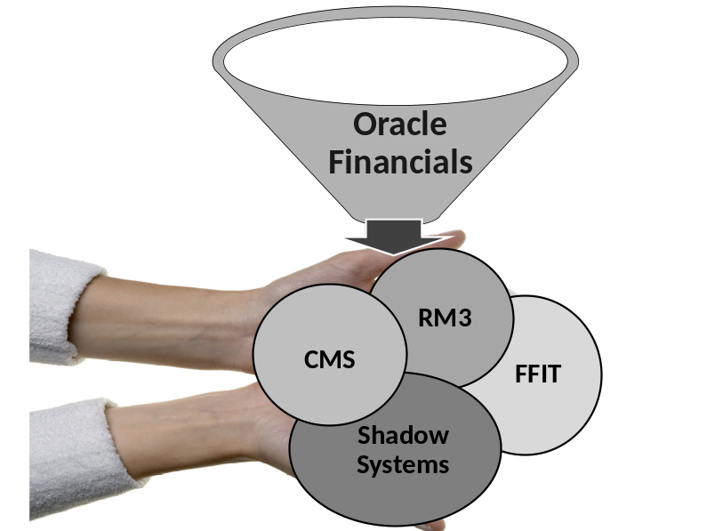

Introduction

Those who manage accounts at Stanford have abundant robust tools available to them. It is up to them to leverage the features of each tool in the way that can best serve their business needs. We provide a brief description of ReportMart3, Faculty Financial inquiry Tool (FFIT), and Shadow Systems, and discuss the Commitment Management System(CMS) in detail.

CMS Commitment Management System
- CMS is a planning and forecasting tool.
- Hard commitment & expenditure data from Oracle Financials is fed nightly to CMS.
- Revenue data is not fed to CMS.
- Users with Update Authority can forecast by:
  - Modifying “hard commitments”
  - Adding “soft commitments”
  - Creating soft budgets
  - Creating custom periods
- Forecasts created in CMS do not alter commitments in Oracle Financials.
- Actual expenditures replace forecasted numbers as the project progresses, which allow financial managers to get an early warning of potential overdrafts, note conflicting commitments, plan future actions, etc.
Checklist: Steps to Implement CMS to Forecast, Report, and Reconcile PTAs
- Learn about CMS at the CMS website (http://cms.stanford.edu)
- Schedule a CMS Overview Presentation for your management team (optional)
- Make certain everyone is granted the appropriate authority to use CMS
  - Managers grant individuals authority in the Authority Manager
  - Individuals complete required CMS training for Update Authority by
registering in STARS for ORA-1129
- Ensure your computer is set up for CMS
- Use CMS to forecast, report, and reconcile PTAs
- Improve business processes and eliminate or reduce use of Shadow Systems

- Learn About CMS at the CMS Website
http://cms.stanford.edu

- Schedule a CMS Overview Presentation for Your Management Team (optional)
Contact Patti McCabe (pmccabe@stanford.edu) to schedule a 1-hour presentation for your team.

- Ensure Everyone is Granted the Appropriate Authority & Completes Required Training to Use CMS (http://cms.stanford.edu → CMS Authority
Using the Stanford Authority Manager, you can be granted one of four authority roles in CMS. Your authority role controls whether you can create forecasts or just view forecasts others have created. It also controls whether you can view or update salary or are limited to non-salary.

View Authority
Two levels available:
- CMS Salary View - includes both salary and non-salary (i.e., goods and services) transactions.
- CMS Non-Salary View - includes only non-salary (i.e., goods and services) transactions
- Both must be granted by your manager
- Matches your current RM3 authority
- Allows you to view forecasts created by others for your PTAs

Update Authority

Two levels available:
- CMS Salary Update - includes both salary and non-salary (i.e., goods and services) transactions.
- CMS Non-Salary Update - includes only non-salary (i.e., goods and services) transactions.
- Both must be granted by your manager
- Both require you to complete training before using CMS
- Both allow you to forecast for your PTAs
- Both include View Authority

Your authority will control which screens or features you can access. For example, if you do not have salary authority, you will be able to access total salaries rollup ONLY, and you will not be able to access information below the total salaries rollup.

Your authority dictates the updates you can perform in CMS. You can update PTA lines over which you have been granted authority. If you share costs (salary or goods & services) with another Org, you can view the entire distribution in CMS even if you do not have authority over all the PTAs. However, you will be able to update only the lines for which you have authority. Stanford Policy on confidentiality of data applies.

Receiving/Granting Authority & Required Training

Receiving CMS Authority is a two-step process:
- You must complete a training class which consists of an overview, practice in the CMS Training Environment, and 5 authority tests. You can take the training either in a hands-on lab or online. You must have approval from your manager to take CMS Training. CMS has contextual help throughout the application to guide the user.
- When you enroll in ORA-1129, Overview of CMS, in STARS, a CMS team member will contact your manager to ensure you are authorized to take the training, determine which authority role you will have, and identify the Orgs and/or Project-Tasks to give you authority for in the CMS Training Environment.
- Once you complete the training, a CMS team member will notify your manager that they can grant you authority via the Authority Manager for the Orgs and/or Project-Tasks you need access to in CMS. You can then begin using CMS.
Managers have the option of allowing the CMS team to upload the authority on their behalf or performing the task manually. Contact Patti McCabe for further information on how authority is being performed in your school.

4. Computer Setup for CMS
http://cms.stanford.edu → Getting Started → Computer Setup
For PC, use Internet Explorer ONLY.
For MAC, use CITRIX

5. Use CMS to Forecast, Report, and Reconcile PTAs
https://ofweb.stanford.edu

- Discuss PTA nickname feature and nickname conventions with your group.
- Discuss roles and responsibilities for PTAs in CMS – remember, everyone who has authority can update the same PTA.
- CMS allows you to view and report on the data from many source systems, i.e., PeopleSoft, GFS and iProcurement.
- CMS is a user interface for Oracle – in Oracle, you pull data via ReportMart3 Reports; in CMS, data is pushed to you by your search criteria. Because of this, you may view data you did not know existed or thought was inactive. If necessary, correct the data you feel is old or incorrect in the source system(s).
- CMS allows you to modify all aspects of pay, including labor distribution & salary update.
- CMS allows you to view the pay history for all personnel – faculty, staff and students.
- CMS allows you to forecast leave and other supplemental pay.
- CMS allows you to add “soft” commitments, including burden.
- CMS has direct links to Oracle Web Inquiry where you can view and/or suppress a PO.
- CMS allows you to view outstanding commitments and actual expenses for Goods & Services which can make reconciliation easier.
- Reduce time spent entering data manually into Shadow System(s) by using CMS Reports, or exporting data to spreadsheets.

6. Improve Business Processes
After everyone in the work group, including the manager, has used CMS, meet to discuss the following:
- Can business processes be streamlined and improved using CMS?
- Are there ways to eliminate manual data entry into Shadow Systems?
- Is it possible to eliminate some Shadow Systems?
- What are the best uses for CMS Report?

CMS Benefits for Administrators
- Reduced audit exposure as CMS allows you to forecast and make better financial decisions.
- Reduced time correcting errors as users have a tool that will “do it right the first time”.
- Eliminates late cost transfers which can result in the PI having to absorb the cost.
- Reduced time spent to produce forecasts and reports.
- Reduced time spent manually entering data and manual calculations.
- Reliable CMS auto-calculations result in accurate data in forecasts and reports.
- Hard commitment data feeds are timely, accurate, and reliable.
- Ability to easily manipulate data to create “what if scenarios”.
- Less time required to provide better financial management.
- PI satisfaction with the results of CMS analysis; problems are identified and corrected early and late transfers and overdrafts are reduced.

Benefits for Faculty
- CMS forecasts and reports are easy to read and interpret.
- Consistent reports from all departments and schools save time and reduce confusion.
- Fewer unpleasant surprises at Closeout.

What Users Are Saying About CMS
CMS Reports
CMS allows administrators to provide uniform and consistent reports to the entire department/school/university, which is a major benefit to those doing interdisciplinary research.
The Month by Month Burn Rate by PTA report shows actual expenses and outstanding commitments.
Reports in CMS are clear, meaningful and easy for your PI to read.
Forecasts automatically default to FY for non-sponsored awards and PTD for sponsored awards.
You can create a Custom Period providing the ability to report for a different time period then the default period.
You can create a Custom Budget which allows you to rearrange expenditure types (with more or less detail) and you can even modify the bottom line dollar amount. This feature is especially powerful if you anticipate more funding and want to forecast using that figure.
You can download report data to Excel in two formats (with header or data dump) so you can easily perform scenario analysis.
Your reports can be labeled with “nicknames”, a more meaningful description for some faculty than the PTA – unlike the Labor Schedule report!

CMS Auto Calculations
You tell CMS when someone is going on vacation and CMS calculates vacation credits taking into consideration weekends, holidays and days in a given month. CMS distributes the leave credit to all PTAs the employee is charged to.
Burden is automatically calculated showing the actual rate on all soft commitments.

CMS is Easy to Use
You can retrieve PTAs by PI.
It is easy to generate new soft commitments and modify existing hard commitments.
You can easily create alternative scenarios for PIs (e.g. cost of hiring one vs. two grad students).
You can easily check for outstanding commitments.
Assists in Closeout by allowing one to easily view outstanding commitments.
You can link to iProcurement to review and reconcile Purchase Reqs/orders.
You can see data from PeopleSoft, HRMS, GFS OF merged into one place.
You can get a PTA balance quickly.

Cool Stuff
You can view people with multiple assignments.
You can view all allocations for people in your Org, being paid from an Org outside your authority.
You can click a PO to view an actual invoice.
Alerts.
You can link directly to Oracle Web Inquiry from CMS to “suppress” a commitment.

Time Savers
View salary history showing 6 months of actual pay to insure people were paid correctly.
View just the current year for a Blanket PO that covers 5 years of a grant - saves manually removing data from RM3.
CMS is one-stop shopping for reviewing hard commitments.
You can quickly suppress commitments.

CMS Report Attributes

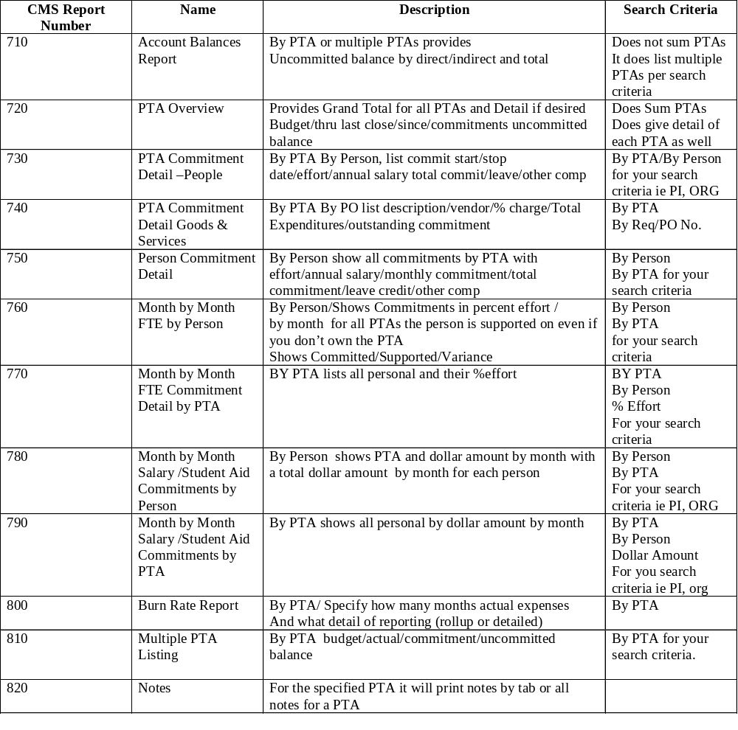

Data Feeds to CMS
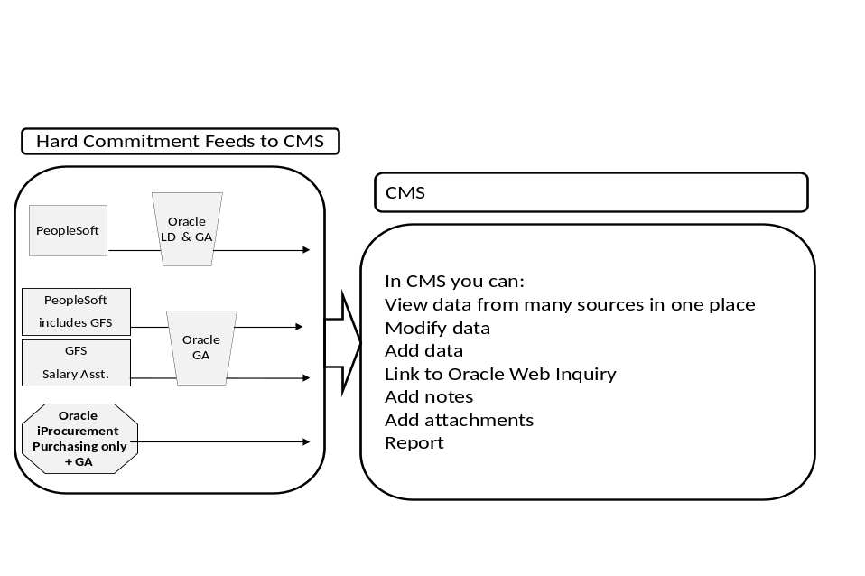
Other Tools

FFIT Faculty Financial inquiry Tool
- Helps faculty manage their University financial resources, which they own as individuals.
- A faculty member can see all Awards, Projects and Tasks which he/she owns.
- Provides balances and drill-down transaction details for a faculty’s individually owned Awards, Projects, Tasks.
- Contains data that is refreshed daily.
- Calculates balances using budget, revenue, expenditure and commitment data.
- Provides online help in the form of tips and downloadable quick guides.
- Optionally, shows allocations to others from the faculty member’s Awards.
- Includes revenue as well as budget data for PTAs.

ReportMart 3
ReportMart3 (RM3) is the primary reporting tool and environment for the financial data in the Oracle Financials system. Key modules of the Oracle Financials system (used by distributed users across campus) include:
- Internet Procurement
- iBudgets
- iJournals
- iOU, PCard
- Labor Distribution

Shadow Systems
Highly customized Excel spreadsheets created by individual administrators to meet the very specific needs of the faculty members they support.

