TPT PhotoVoice Project

Due Date:

Assignment: During the next week, you will take photos around your neighborhood, school, and home where you are exposed to tobacco, e-cigarettes/vapes, or any other tobacco products.

Your photos can include images of advertisements, trash or waste from tobacco products, places you often see people using tobacco, and any times your environment discourages you from using tobacco.

Select 10 to 15 of your photos and develop a report that displays your photos and includes a 2- to 3-sentence description of why you took that photo and how it is related to your personal feelings about tobacco.

Reminder: Respect privacy, be sure to ask people before including them in any of your photos.

Example:

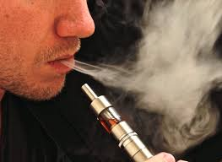 | This is a picture I took of my older brother. He’s been using vapes for about a year now and just started smoking regular cigarettes too. I wish he wouldn’t smoke so often because our little sister looks up to him a lot and I worry that she might start smoking too.

